False.

Counterexample:

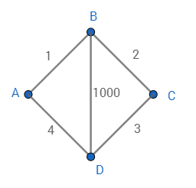

Both ({A, B, D}, {C}) and {(A), (B, D, C)} are minimum cuts between A and C.

Note that maximum flow between A and C is 5, which is the same as minimum cut between A and C.